LAB ASSIGNMENT-16.3

Task Description #1 – Schema Generation
Task: Ask AI to design a schema for a Library Management System (Tables: Books, Members, Loans).

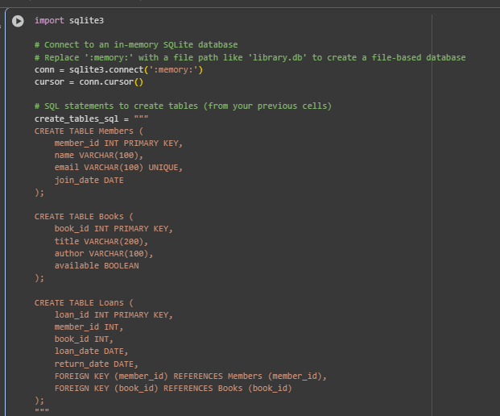

Task Description #2 – Error Insert Data
Task: Ask AI to generate INSERT INTO queries for the schema above (3 sample records per table).

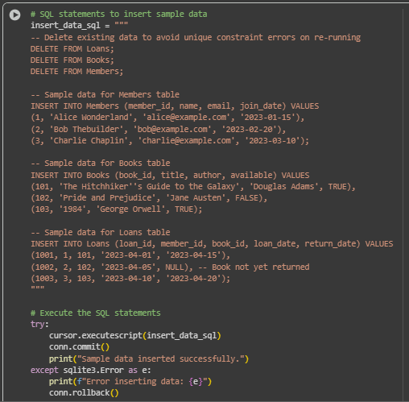

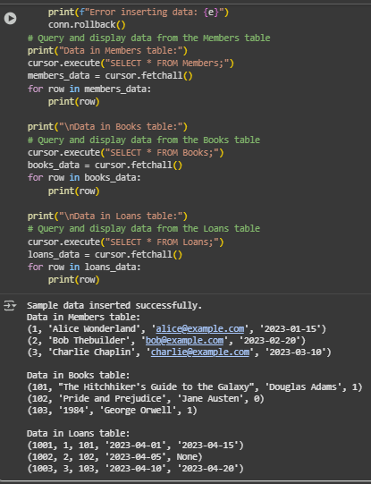

Task Description #3 – Basic Queries
Task: Use AI to generate a query to list all books borrowed by a specific member

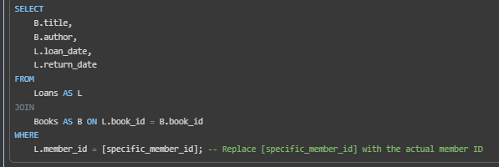

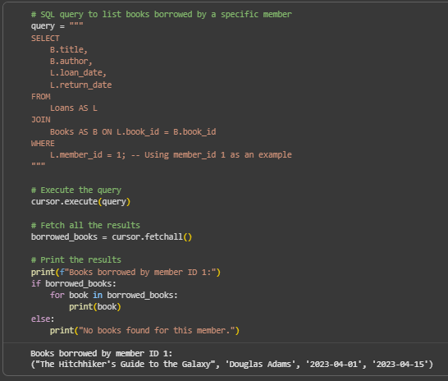

Task Description #4 – Update and Delete Queries
Task: Generate queries with AI for:
- Updating a book’s availability to FALSE when borrowed.
Deleting a member record safely.

